Mykhailo BURYCHENKO¹, Ph.D., associate professor
Yurii ONIKIENKO², Ph.D., associate professor
Marina ARCHIREY³, assistant
¹National Aviation University, Kyiv, Ukraine, e-mail: bmu044@gmail.com
²"SIEMENS MEDICINE", Kyiv, Ukraine, e-mail: yurii.onykiienko@gmail.com
³ National Aviation University, Kyiv, Ukraine, e-mail: marina_arkhirey@ukr.net

TITLE OF THE REPORT

Abstract. ……………………………………………………….…………………………………
………………………………………………………………………………………………………………………………………………………………………………………………………………………………
Keywords: ………………………………………………….……………………………………..

Relevance of research. …………………………………………………...……………….
………………………………………………………………………………………………………………………………………………………………………………………………………………………………
The aim of the study……………………………………………………………………… …………………………………………………………………………………………………...…
…………………………………………………………………………………………………….……………………………………………………………………………………………………………….…………
Basic research materials. In work [1] for definition ………………………………………
……………………………………………………………………………………………………….……………………………………………………………………………………………………………….………

The results.……………………………………………………………………………….
………………………………………………………………………………………………………………………………………………………………………………………………………………………………
………………………………………………………………………………………………………………………………………………………………………………………………………………………………………………………………………………………………………………………………………………………………………………………………………………………………………………………………………………………………………………………………………………………………………………………………………………………………………………………………………………………………………………………………………………………………………………………………………………………………………………………………………………………………………………………………

Examples of design figures: fig. 1.

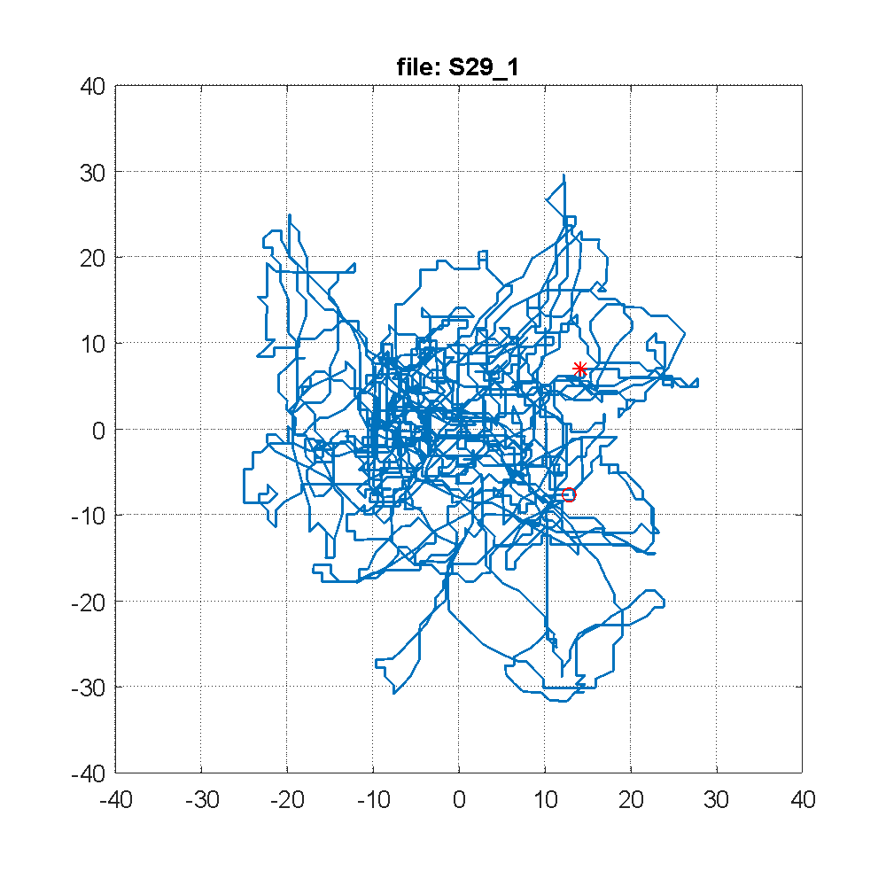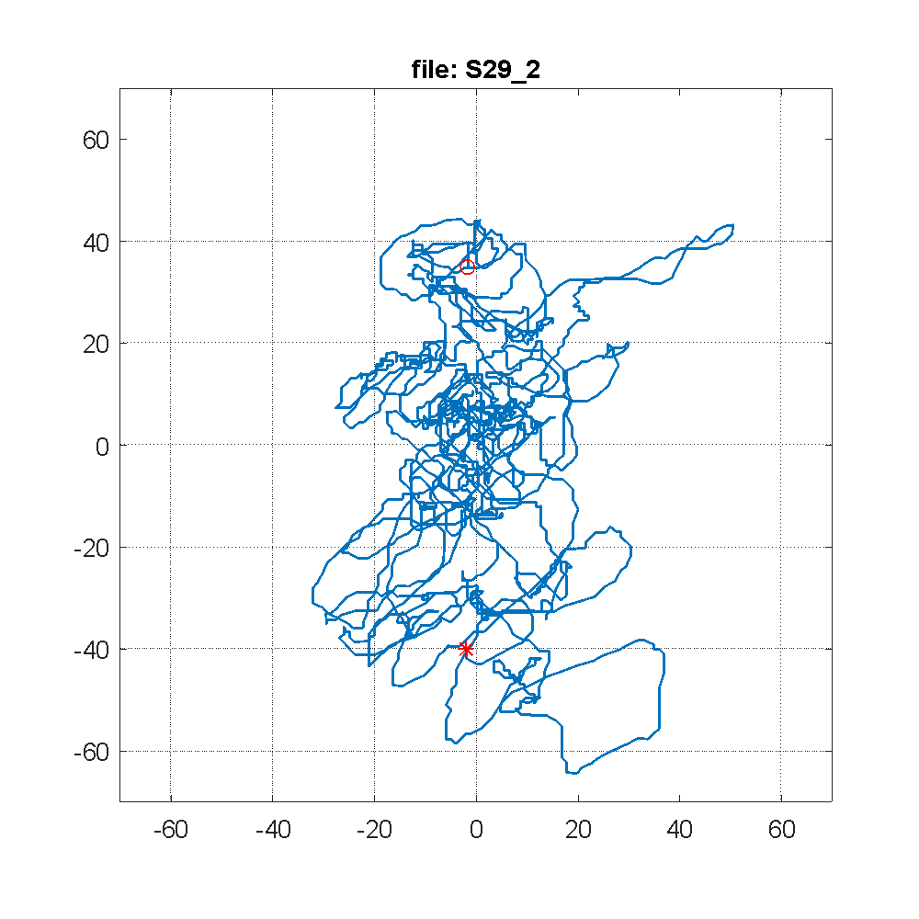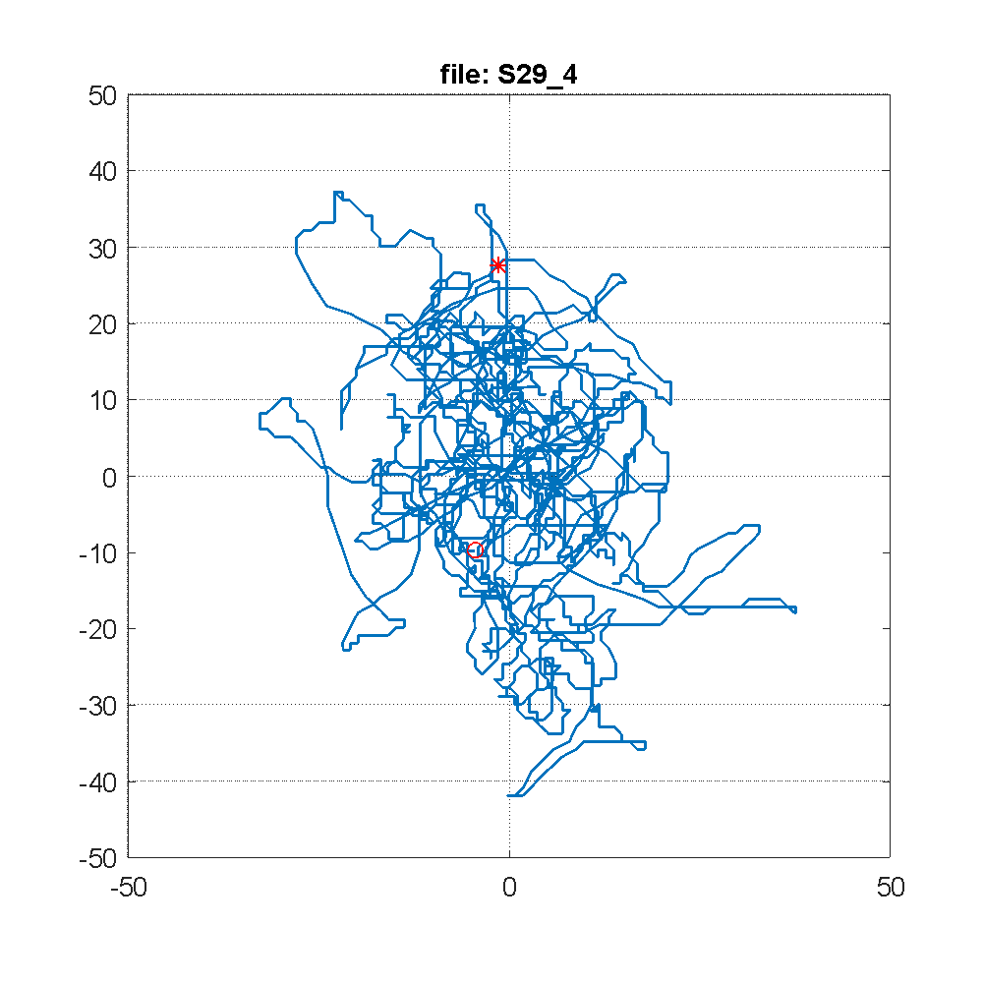
Fig. 1. Name of the figure

………………………………………………………………………………………………………………………………………………………………………………………………………………………………
………………………………………………………………………………………………………………………………………………………………………………………………………………………………………………………………………………………………………………………………………………………………………………………………………………………………………………………………Conclusions.…………………………………………………………………………………………………………………………………………………………………………………………………………………………………………………………………………………………

Reference

1. Onykiienko, Y. (2019). Method for Research of the Human Static Equilibrium Function. Advances in Computer Science for Engineering and Education. ICCSEEA 2018. Advances in Intelligent Systems and Computing, vol. 754. Springer, Cham. https://doi.org/10.1007/978-3-319-91008-6_53
2. Schlenker J. Schlenker T., Nedělka T., end all. Recurrence Quantification Analysis: A Promising Method for Data Evaluation in Medicine. December 2014. DOI: 10.24105/ejbi.2014.10.1.7
3. M. S. Lyby, M. Mehlsen, A. B. Jensen and all. Intervention and Reductions in Distress Symptoms in Women With Breast Cancer. Front. Appl. Math. Stat., 30 July 2019. Sec. Dynamical Systems Volume 5 – 2019. https://doi.org/10.3389/fams.2019.00037.
4. Kirichenko L., Radivilova T., Stepanenko J Applying recurrence plots to classify time series.. COLINS-2021: 5th International Conference on Computational Linguistics and Intelligent Systems, April 22–23, 2021, Kharkiv, Ukraine). https://ceur-ws.org/Vol-2870/paper128.pdf

